**Case Study 1**  
**Project Overview:**

This is a concept network design and project estimation for a small car dealership with 4 sales offices, a garage area, a reception office and a server room. Each office is fitted with a computer for access and also has shared printers. The service area is fitted with wireless printers and laptops for the service employees. The dealership also has a server on the premises for customer appointment management and payment processing.

**Proposed Network Design:**

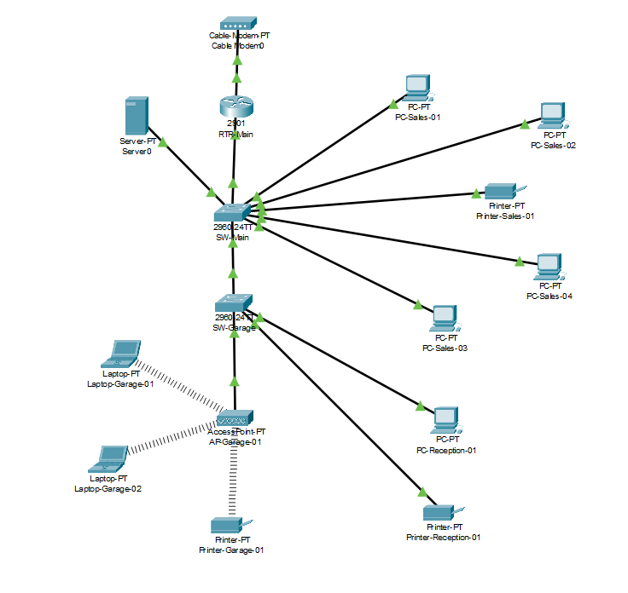

**Hardware Components and Cost**

|  |  |  |  |
| --- | --- | --- | --- |
| **Component** | **Location** | **Quantity** | **Cost** |
| Router (Meraki MX75) | Server Room | 1 | 600$ |
| Switch (Aruba 1930) | Server Room | 1 | 400$ |
| Switch (Aruba 1930) | Garage | 1 | 400$ |
| Server | Server Room | 1 | 4500 $ |
| Computer (Dell) | Sales | 4 | 600x4 = 2400 |
| Printer (Brother) | Sales | 1 | 900$ |
| Access Point (Meraki MR36) | Garage | 1 | 390$ |
| Laptop | Garage | 2 | 800x2 = 1600$ |
| Printer (Brother) | Garage | 1 | 900$ |
| Computer | Reception | 2 | 600x2 = 1200$ |
| Printer | Reception | 1 | 900$ |
| Cable Drop |  | 12 | 3000$ |
| Labor |  | 40 hours | 5,000$ |
|  |  | **Total** | **22,190$** |

**IP Addressing:**The IP address space chosen for the dealership is the 192.168.100.0/24 range. The addresses for the Router, Switches, Access point and the Server are assigned statically while the end user components such as printer, laptop and computer receive the IP address via DHCP static leases.

|  |  |
| --- | --- |
| **Hostname** | **IP Address** |
| RTR-Main | 192.168.100.1/24 |
| SW-Main | 192.168.100.2/24 |
| SW-Garage | 192.168.100.3/24 |
| AP-Garage-01 | 192.168.100.4/24 |
| Server-01 | 192.168.100.10/24 |
| PC-Sales-01 | 192.168.100.100/24 |
| PC-Sales-02 | 192.168.100.101/24 |
| PC-Sales-03 | 192.168.100.102/24 |
| PC-Sales-04 | 192.168.100.103/24 |
| Printer-Sales-01 | 192.168.100.104/24 |
| Laptop-Garage-01 | 192.168.100.110/24 |
| Laptop-Garage-02 | 192.168.100.111/24 |
| Printer-Garage-01 | 192.168.100.112/24 |
| PC-Reception-01 | 192.168.100.120/24 |
| PC-Reception-02 | 192.168.100.121/24 |
| Printer-Reception-01 | 192.168.100.122/24 |